Sean de Villiers

SilverhorseAPIBackend Deployment Manual

Contents

Dependencies 2

IIS 2

DotNet Hosting 2

Publishing Code For Deployment 3

Visual Studio 2019 3

IIS 5

# Dependencies

## IIS

Make sure IIS is installed on the Host Computer, it can be installed by Adding internet Information Services in the “Turn Windows Features on or off” Settings panel

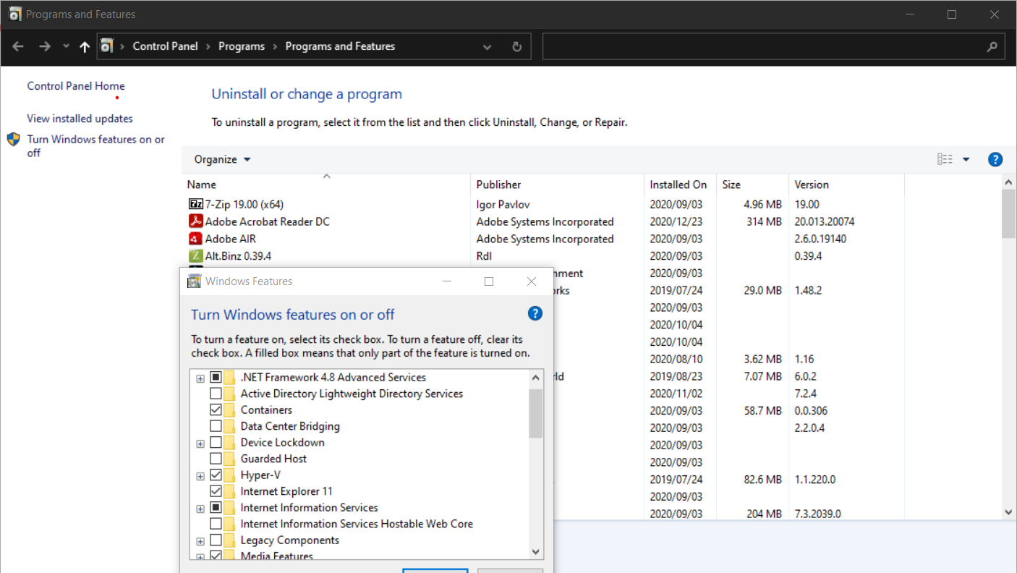

## Dot net Hosting

Download the dotnet-hosting-5.0.2-win.exe from <https://dotnet.microsoft.com/download/dotnet-core/thank-you/runtime-aspnetcore-5.0.2-windows-hosting-bundle-installer>

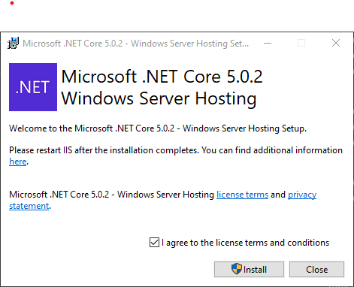

Install dotnet-hosting-5.0.2-win.exe.

# Publishing Code for Deployment

## Visual Studio 2019

Open Visual Studio and Click Publish

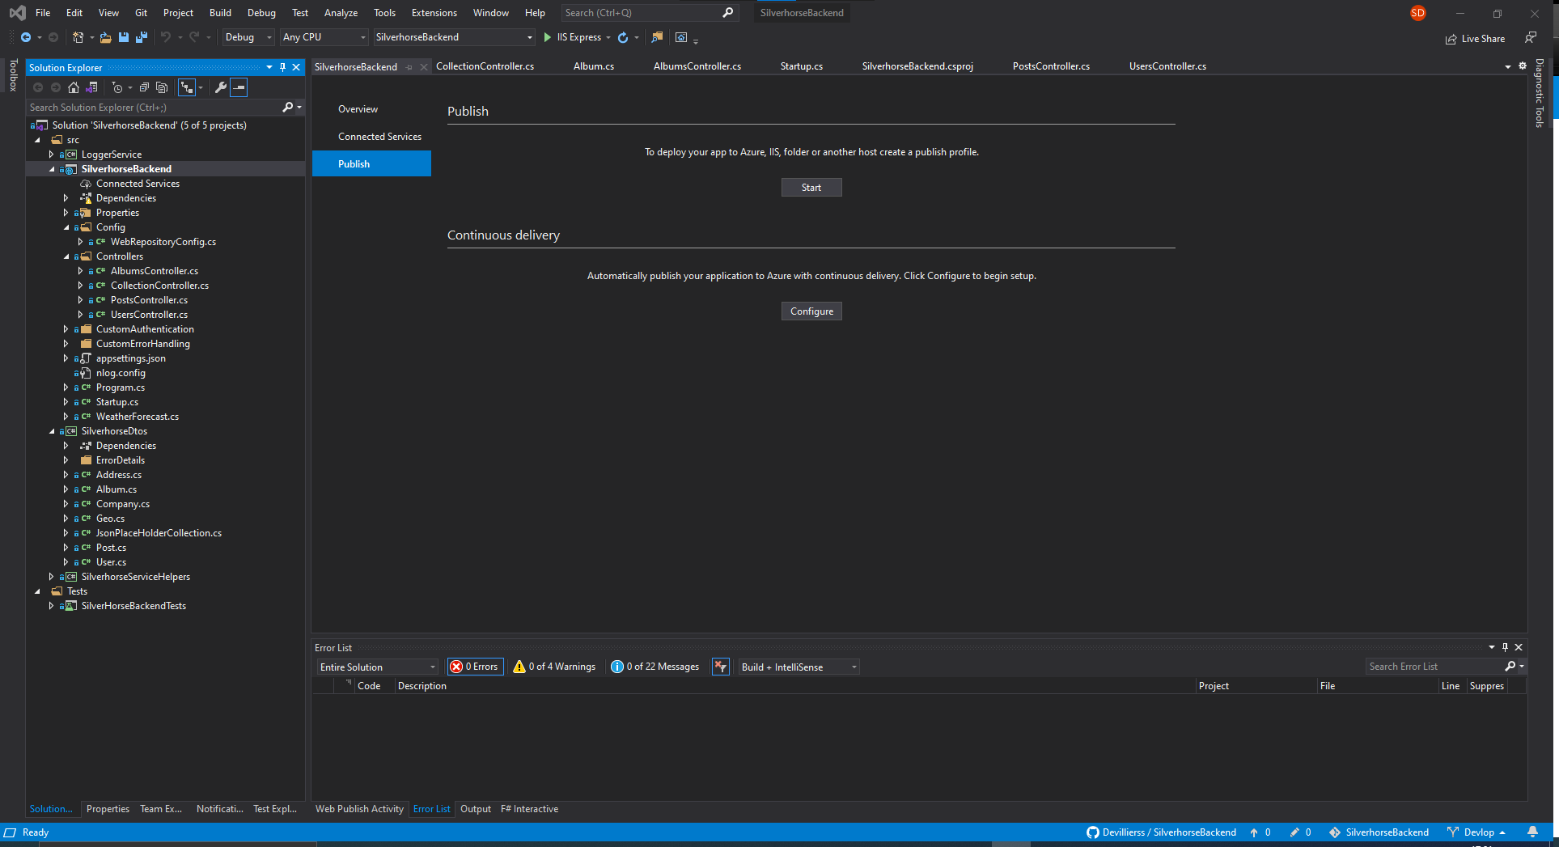

Clicks Start Under Publish

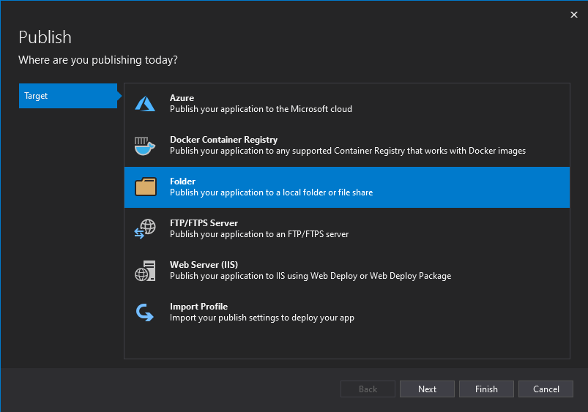

Select Folder and next

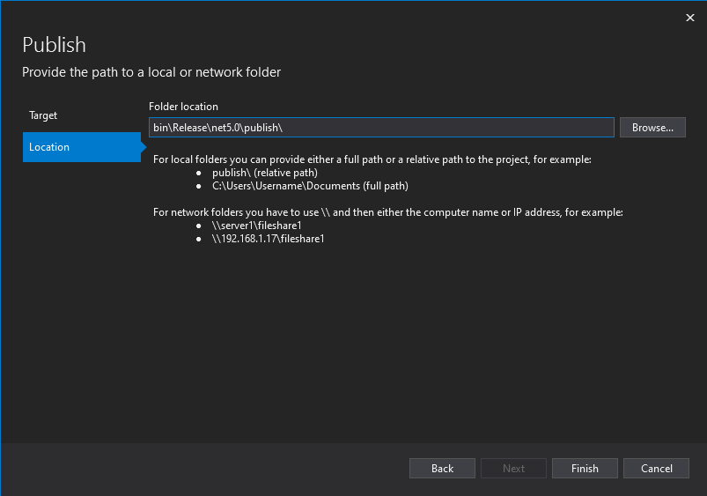

Fill in folder location and click finish

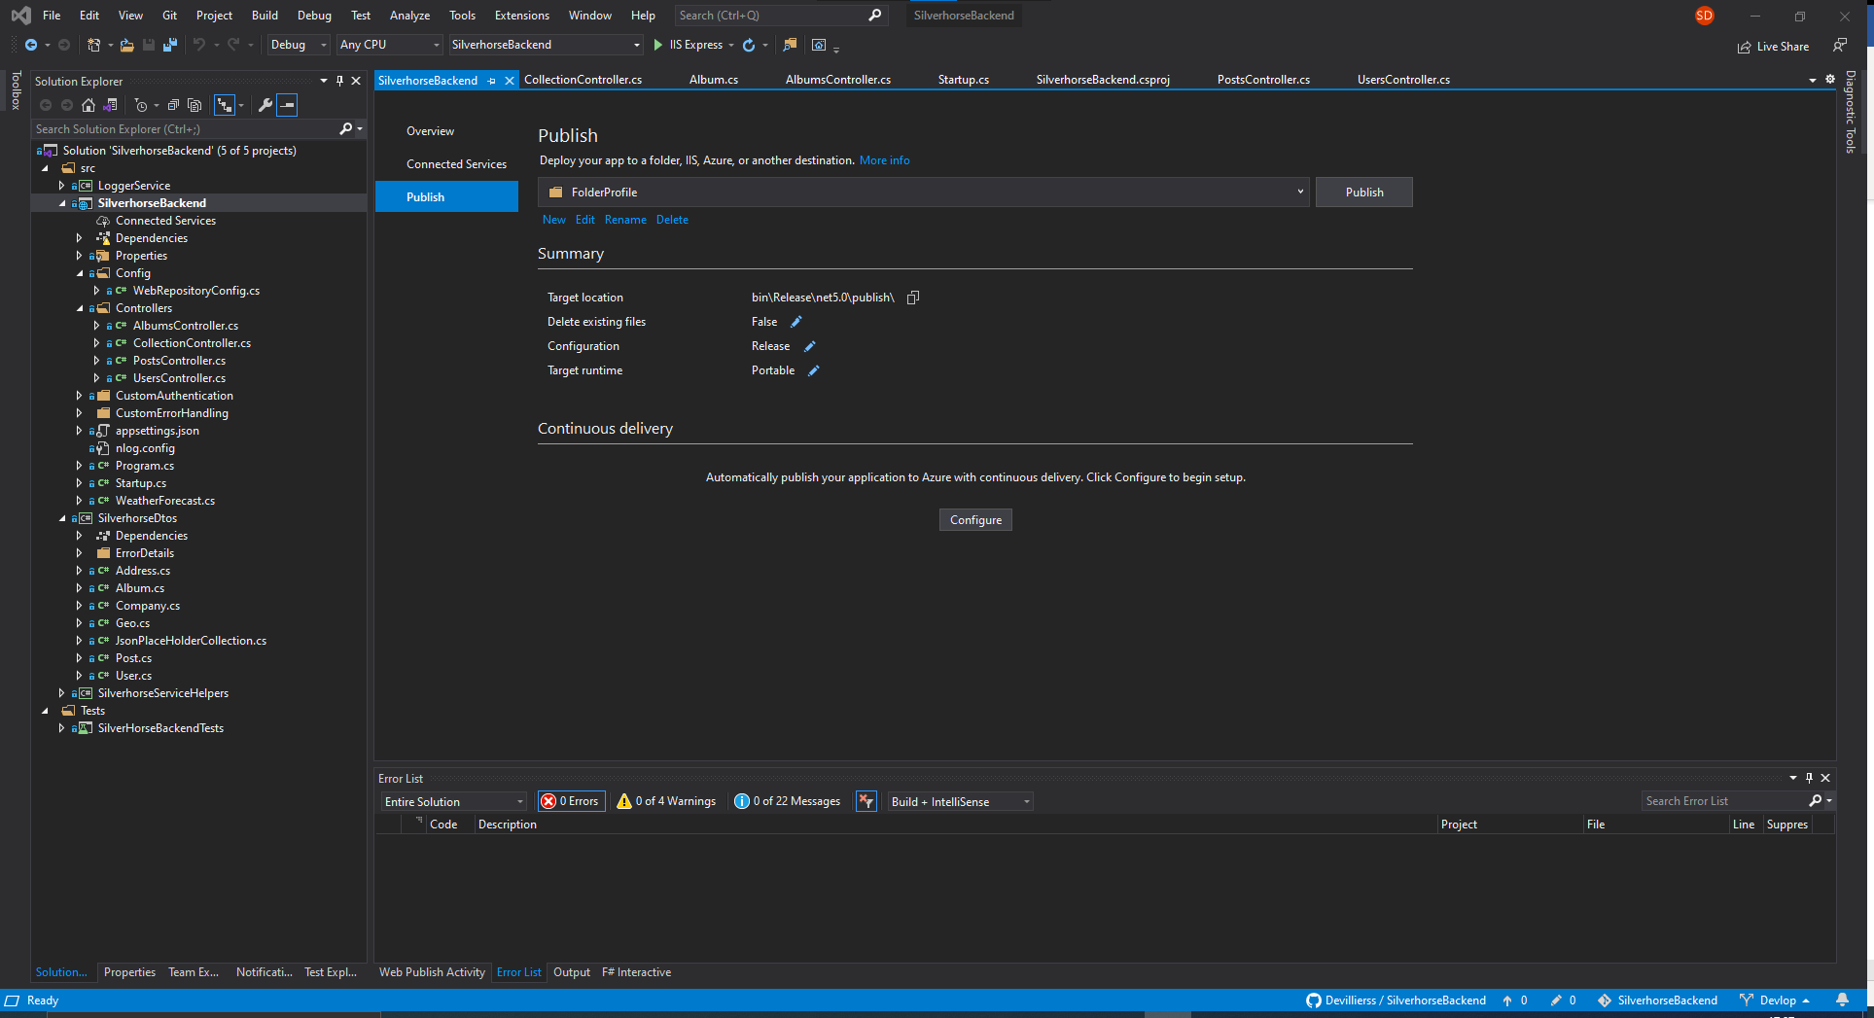

Click Publish

The Published files will be written to the location specified above.

Copy Published Folder files to IIS Web server location that you would like to make use of

## 

## IIS Server Configuration

Open IIS on the host Web Server.

Right Click Application pools add a new Application Pool if a dotnet core application pool does not exists. The screen below will pop up and should be filled in.

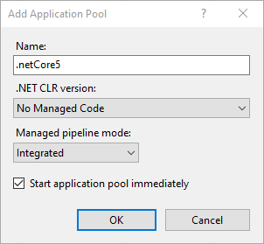

Press Ok then move to the add website screen.

Fill in the add website screen with the relevant information for your system.

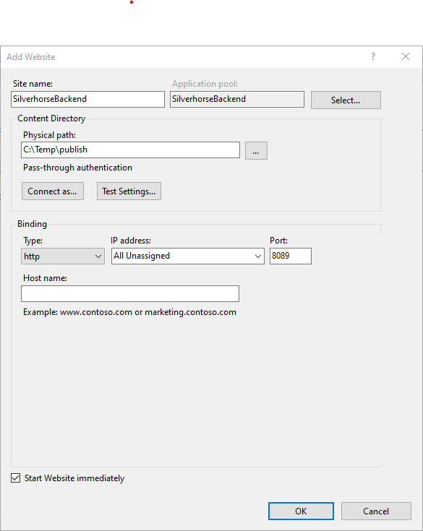

Once complete press ok.

Start the website and browse to <http://localhost:8089/swagger/index.html> if installed locally.

You should see the swagger page displayed. From here you can test directly from swagger once the Authorise token is added.

Alternatvly you can use the postman scipt provided as part of the git repository.